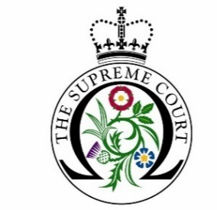

Debate Day Programme 2021 – 2022 Application Form

Name and address of educational institution:

Status of your educational institution (i.e., state, grammar, independent, etc)

Name and direct contact details of group organiser:
(Name, position, telephone number and email address)

What year group(s) will the participants be and what subjects/course(s) are they studying?

How many people will be in your group, including staff?
(please note, we require a minimum of 11 students and an absolute maximum of 25)

Please state if you would like a physical or virtual session: (NB for the details of a virtual tour please see Terms and Conditions no. 6)

Debate Days take place on Fridays either 11 am – 3 pm or 2 pm - 5 pm. On this basis, please give three preferred dates between November 2021 and May 2022.

Has your educational institution participated in a Debate Day workshop at the Supreme Court in previous years? If yes, please give dates.

Please give any details of any widening participation schemes your school/college is involved in

Please give the Ofsted free school meals rating:
Lower than average
Average
Higher than average
Please tick this box to confirm that you have read and fully agree to the UKSC Debate Day Programme Terms and Conditions.

Please return this form to enquiries@supremecourt.uk by 4 October, 2021.

