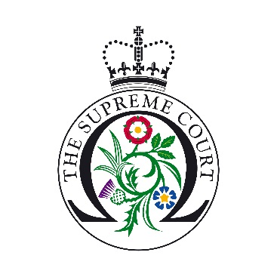

UK Supreme Court Ask a Justice Application Form
The Supreme Court is offering students the opportunity to have a live question and answer session with a justice from their own classroom.
These sessions give students with a keen interest in law a unique chance to meet and speak with a justice. Each session will offer 10 students the opportunity to speak for approximately three minutes with the justice. The entire session will last no longer than 30 minutes.
We will seek to prioritise schools and colleges from the wider UK: Northern Ireland, Scotland, Wales, North and South West of England.
Teacher’s Name:
School:
Year Group:
(Years 11-13 in England and Wales; Years 12-14 in Northern Ireland; S5 and S6 students in Scotland)
Email address:
Contact number:
Address:

Where did you hear about the programme?

Subjects studied by the students/their interests/career aspirations:

100 words on how the school meets the criteria, why you would like to take part in the programme and how taking part will benefit the students:

Name of IT manager at the School:

Skype account name:

Please tick this box to confirm you have access to an Ethernet Cable (this is essential to take part in the scheme)

Please see the educational resources available on our website (https://www.supremecourt.uk/learning-resources.html) in order to inform students about The Supreme Court and its role prior to the session.

The deadline for submission is 15th November 2019. Thank you for you application, candidates will be contacted by December 2019.

