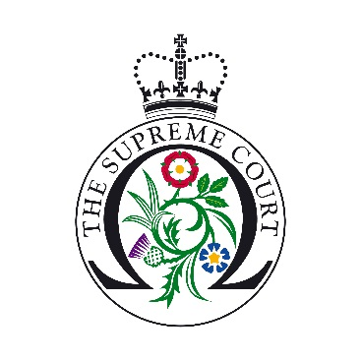

UK Supreme Court Ask a Justice Application Form
The Supreme Court is offering students the opportunity to have a live question and answer session with a justice from their own classroom.
These sessions give students with a keen interest in law a unique chance to meet and speak with a justice. Each session will offer 10 students the opportunity to speak for approximately three minutes with the justice. The entire session will last no longer than 30 - 45 minutes.
We will seek to prioritise schools and colleges from certain parts of the UK: Northern Ireland, Scotland, Wales, and the top 10 areas of multiple deprivation in England.
Teacher’s name:
Click or tap here to enter text.
School:
Click or tap here to enter text.
Year group
Years 11-13 in England and Wales; Years 12-14 in Northern Ireland; S5 and S6 students in Scotland):
Click or tap here to enter text.

Email address: Click or tap here to enter text.

Contact number

Please provide a number so that if anything goes wrong during the IT test or on the day of the session, it will be easy to contact you:
Click or tap here to enter text.

Address:
Click or tap here to enter text.

Where did you hear about the programme?
Click or tap here to enter text.

Subjects studied by the students/their interests/career aspirations:
Click or tap here to enter text.

100 words on how the school meets the criteria, why you would like to take part in the programme and how taking part will benefit the students:
Click or tap here to enter text.

Is the proportion of students eligible for free school meals:
Below average☐
Average☐
Above average☐

Name of IT manager at the school:
Click or tap here to enter text.

Telephone number of IT manager at the school:
Click or tap here to enter text.

Please tick the box to confirm you will be able to use an ethernet cable during the session.
Please note that by ticking this box you are agreeing that you have the correct equipment to take part in the scheme. If WiFi is used during the IT test, we reserve the right to cancel your session.
☐

Please see the educational resources available on our website in order to inform students about the Supreme Court and its role prior to the session.
The deadline for submission is 29th October 2021. Thank you for your application. Candidates will be contacted by the end of November 2021.

