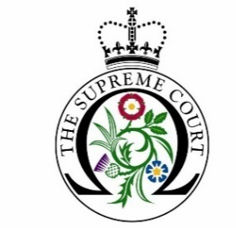

UKSC Debate Day Programme

Application Form | 2023-24

Please read the accompanying terms and conditions before submitting this application form to enquiries@supremecourt.uk. The application deadline is 1st October 2023 at 12pm.
Name and address of educational institution:
Status of your educational institution (i.e., state, grammar, independent, etc)
Name and direct contact details of group organiser:
(Name, position, telephone number and email address)
What year group(s) will the participants be and what subjects/course(s) are they studying?
How many people will be in your group, including staff?
(Please note we require a minimum of 11 students and an absolute maximum of 25)
Please state if you would like a physical or virtual session: (NB for the details of a virtual tour please see Terms and Conditions no. 6)
Debate Days take place on Fridays at 11 am – 3 pm. On this basis, please select three dates from the following available sessions. (We will aim to accommodate everyone; however, we cannot guarantee that you will receive the date of your choosing)
- November 24th 2023
- December 1st 2023
- January 19th 2024
- January 26th 2024
- February 2nd 2024
- February 23rd 2024
- March 15th 2024
- April 19th 2024
- May 17th 2024
- June 21st 2024
Has your educational institution participated in a Debate Day workshop at the Supreme Court in previous years? If yes, please give dates.
Please give any details of any widening participation schemes your school/college is involved in
Please give the Ofsted free school meals rating:
Lower than average
Average
Higher than average
Please tick this box to confirm that you have read and fully agree to the UKSC Debate Day Programme General Terms and Conditions.

